Flipper Zero Standard Operating Procedure (SOP)
Scope: This SOP defines the standard procedure for initial setup, firmware management, and basics of Flipper Zero devices used in authorized cybersecurity labs and training environments.

1. Introduction
Flipper Zero is a portable multi-tool for interacting with access control systems, radio protocols, NFC/RFID, infrared, and GPIO-based hardware. This SOP provides a step-by-step, printable procedure for safely preparing a Flipper Zero for use, including microSD installation, firmware updates via qFlipper, driver configuration, and emergency recovery mode usage.
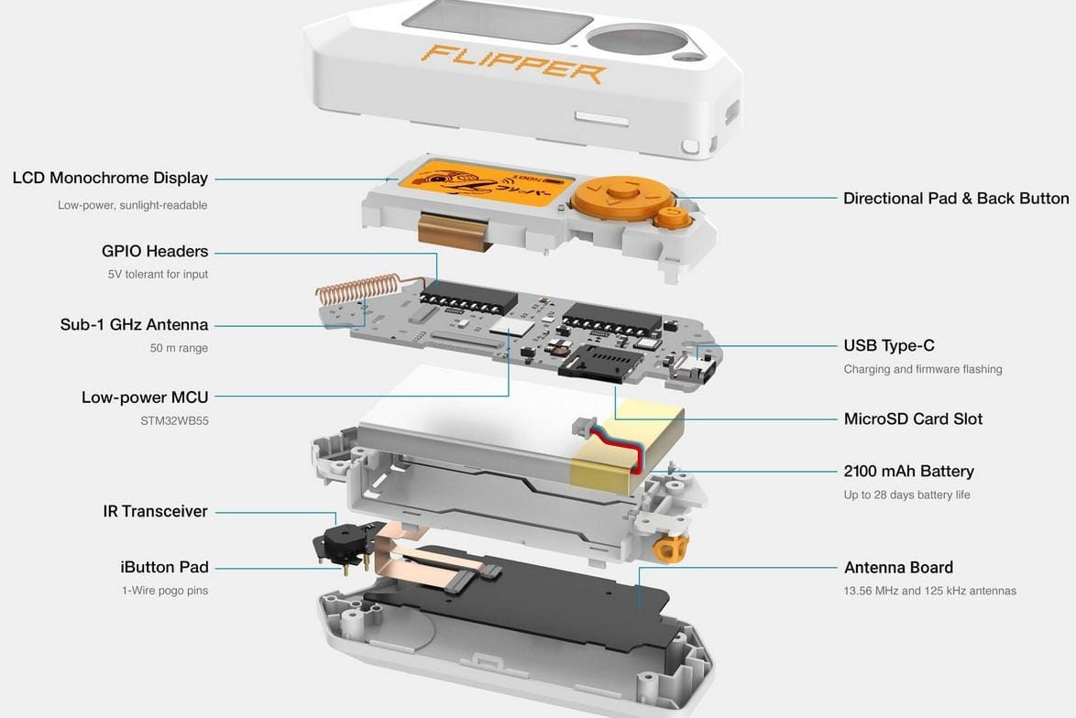
Figure 1.1 — Flipper Zero internal hardware components overview

2. Required Equipment
Each operator must have the following before starting setup:
- Flipper Zero device (unboxed, visually inspected).
- USB-C data cable (not charge-only).
- MicroSD card (8–32 GB recommended, class 10 or better).
- Computer with Linux (primary) or Windows 10/11 (alternate).
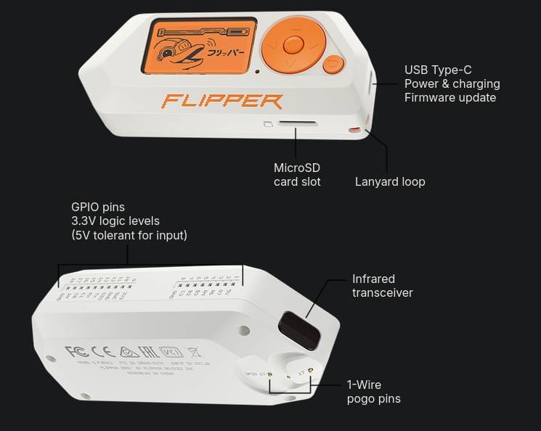
Figure 2.1 — Flipper Zero port layout: USB-C, microSD slot, GPIO pins, IR transceiver, and 1-Wire pogo pins

3. MicroSD Card Setup

3.1 MicroSD Selection
- Capacity between 8 GB and 32 GB is sufficient for most lab use.
- Format as FAT32 if the card is new or previously used in another device.
- Avoid physically damaged or counterfeit cards.

3.2 Inserting the MicroSD Card
- Ensure the Flipper Zero is powered off before inserting the card.
- Locate the microSD slot on the side of the device.
- Align the microSD card with the contacts facing the correct direction (as marked on the device).
- Gently push the card into the slot until it clicks into place.
NOTE: Flipper Zero requires a working microSD card to store Sub-GHz captures, NFC/RFID dumps, IR libraries, and application data. Continue only after the card is fully inserted.

4. First Power-On
- Press and hold the BACK button for approximately 3 seconds.
- Wait for the Flipper Zero logo to appear on the screen.
- Verify that the screen, backlight, and buttons respond.
- If the device does not power on, connect to USB power and retry.
During first boot, the device may prompt for basic preferences such as language, handedness, and time format. Configure these according to lab standards if applicable.

5. qFlipper Installation on Linux

5.1 Download qFlipper
- Open a web browser and navigate to the official Flipper Zero downloads or documentation page.
- Download the qFlipper AppImage suitable for your distribution.
- Save the file to a known folder, for example, the Downloads directory.
- Or simply install using cmd Debian: sudo apt install qflipper Arch: sudo pacman -S qflipper

5.2 Make the AppImage Executable (GUI Method)
- Open the file manager and browse to the downloaded qFlipper AppImage.
- Right-click the AppImage file and choose Properties.
- Go to the Permissions tab.
- Enable the option to allow executing the file as a program, for example, check Executable or similar.
- Close the Properties window.

5.3 Make the AppImage Executable (Terminal Method)
- Open a terminal.
- Change to the folder containing the qFlipper AppImage, for example: cd ~/Downloads
- Run the command: chmod +x qFlipper-*.AppImage
- Verify there are no permission errors.

6. Connecting Flipper Zero to qFlipper (Linux)
- Ensure the Flipper Zero is powered on and the microSD card is inserted.
- Connect the device to the Linux computer via the USB-C data cable.
- Launch qFlipper by double-clicking the AppImage or running it from a terminal.
- Wait for qFlipper to detect the device; device information should appear in the interface.
- If the device is not detected, recheck the cable, USB port, and udev rules.
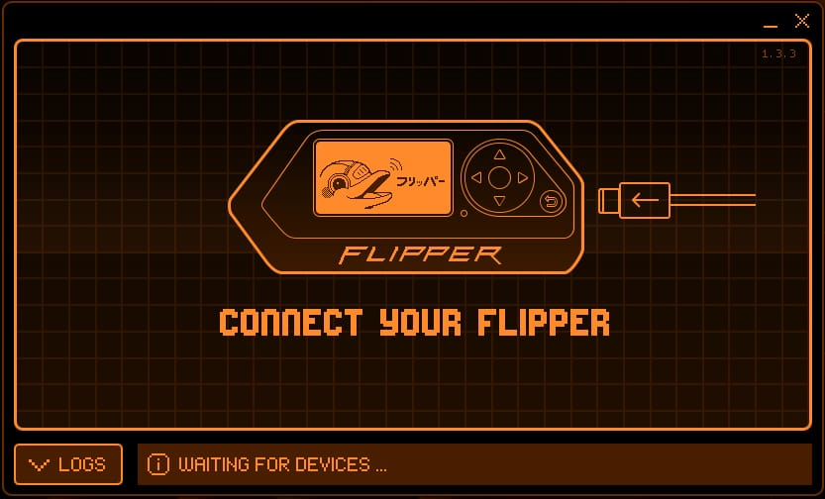
Figure 6.1 — qFlipper waiting for the Flipper Zero device to be connected

7. Firmware Update Procedure

7.1 Choosing Firmware Channel
- Release: Stable, recommended for most users and lab environments.
- Release Candidate: Newer features with near-stable quality; use when you need recent changes with minimal risk.
- Development: Latest experimental changes; may contain bugs; use only for testing when instructed.
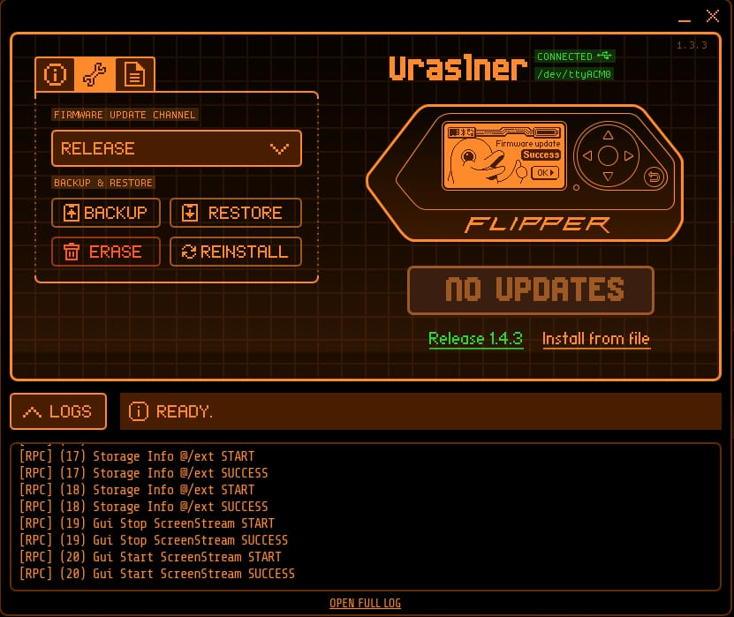
Figure 7.1 — qFlipper Update/Tools tab showing firmware update channel, Backup, Restore, Erase and Reinstall options

7.2 Updating Firmware via qFlipper
- Open qFlipper with the Flipper Zero connected via USB.
- Navigate to the firmware or update section in qFlipper.
- Select the desired firmware channel, typically Release for SOP compliance.
- Click the Update button to start the firmware update. Do not disconnect the USB cable during the update. Wait until qFlipper reports that the update is complete.
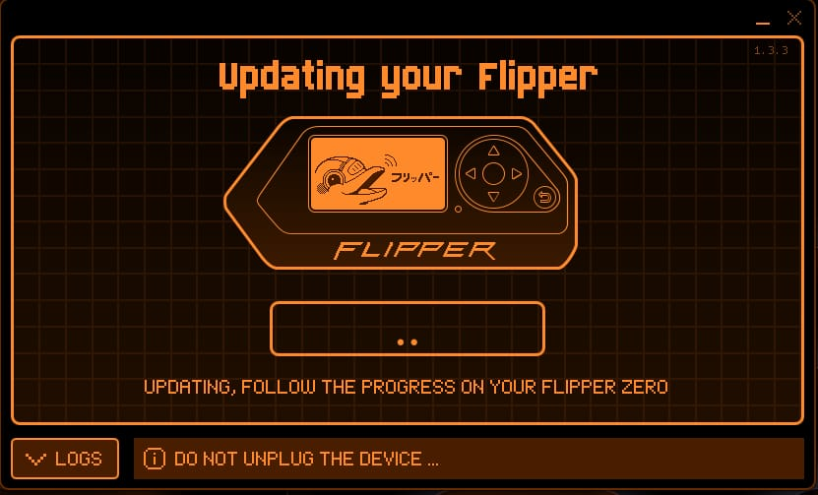
Figure 7.2 — qFlipper update in progress; do not unplug the device during this step
- Allow the Flipper Zero to reboot if prompted.
- Verify the new firmware version in qFlipper or in the Flipper Zero settings menu.
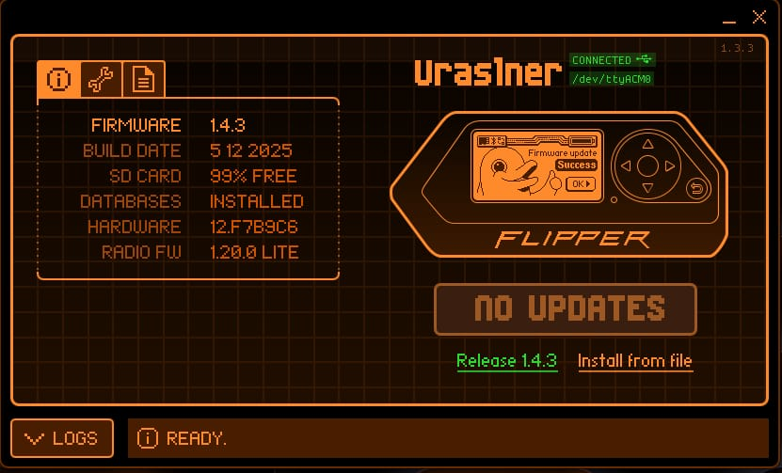
Figure 7.3 — qFlipper Info tab confirming successful firmware update (Firmware 1.4.3, No Updates)

8. Basic Post-Update Checks
- Confirm the device boots to the main menu without errors.
- Navigate through menus using the directional buttons and center button.
- Open the Settings and System menus and verify time, date, and preferences.
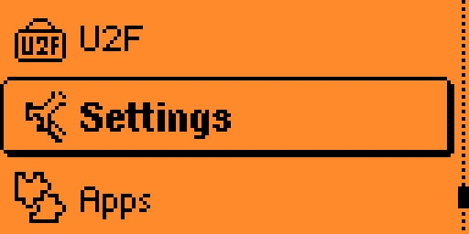
Figure 8.1 — Flipper Zero main menu showing the Settings entry
- Test a basic function, for example opening the Sub-GHz menu, to confirm normal behavior.
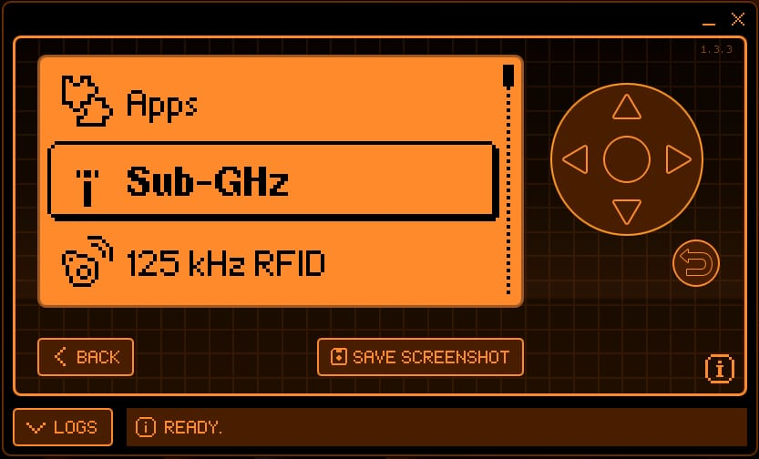
Figure 8.2 — qFlipper remote screen showing the Sub-GHz menu open on the Flipper Zero
- Ensure the microSD card is recognized by checking storage-related menus or apps.

9. File Management via qFlipper
- Open the File Manager tab in qFlipper.
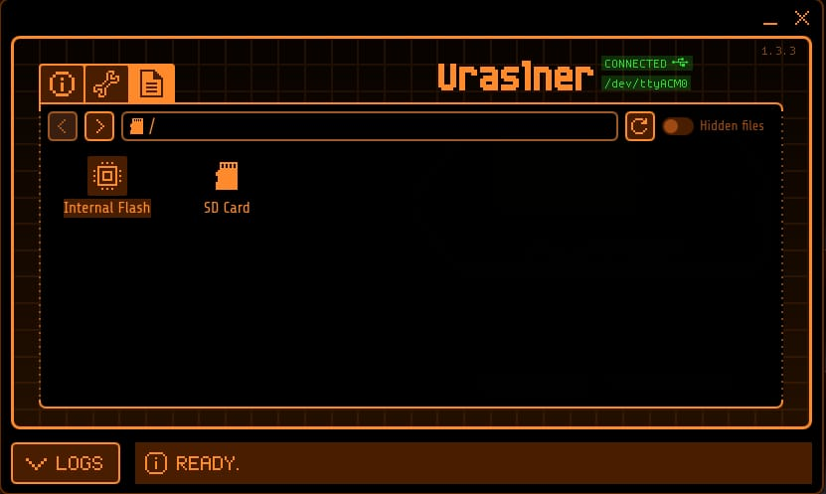
Figure 9.1 — qFlipper File Manager showing the root of the device: Internal Flash and SD Card
- Browse the microSD card directory structure, for example subghz, nfc, infrared, apps.
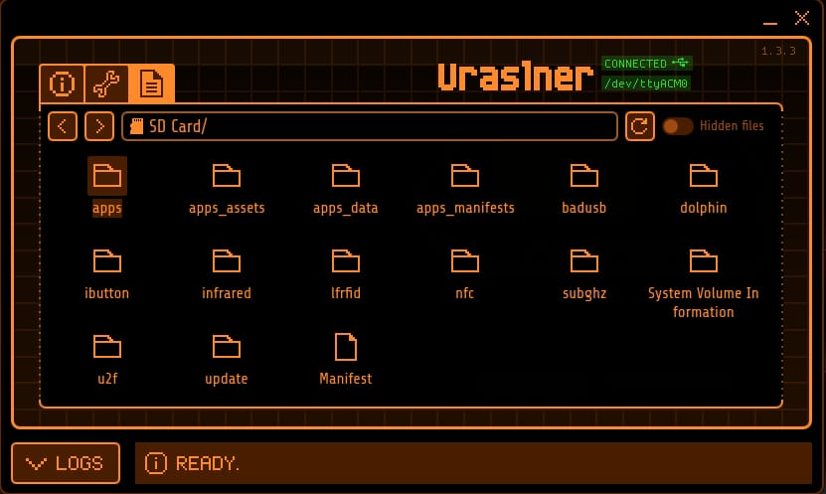
Figure 9.2 — qFlipper File Manager showing the SD Card directory structure (apps, subghz, nfc, infrared, etc.)
- Upload files from the computer to the Flipper Zero using the upload function.
- Delete obsolete or test files according to lab data retention policies.
- Use an external microSD card reader for bulk file transfer if required for speed.

10. Flipper Mobile App on Android (Bluetooth)
The Flipper Mobile App is the official companion application for Flipper Zero on Android and iOS. It allows you to update firmware and databases, manage files on the microSD card, share data online, browse an apps catalog, and remotely control your Flipper Zero from a smartphone using Bluetooth. This section focuses on Android setup and usage so new users can follow a clear, repeatable procedure.

10.1 Prerequisites for Android Setup
- An Android smartphone with Bluetooth enabled.
- The Flipper Mobile App installed from Google Play Store.
- A Flipper Zero with firmware updated to the latest Release channel via qFlipper or Flipper Lab.
- Bluetooth enabled on the Flipper Zero device.

10.2 Enabling Bluetooth on Flipper Zero
- Power on the Flipper Zero.
- From the main menu, navigate to Settings.
Figure 10.1 — Flipper Zero main menu with Settings highlighted
- Open the Bluetooth settings menu.
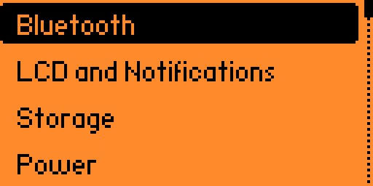
Figure 10.2 — Settings menu showing the Bluetooth entry
- Set Bluetooth to ON.
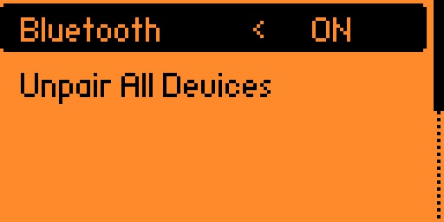
Figure 10.3 — Bluetooth setting switched to ON, with Unpair All Devices option below
- Optionally, clear existing pairings by selecting Forget All Paired Devices if you are troubleshooting.

10.3 Pairing Android with Flipper Zero via Bluetooth
- Ensure Bluetooth is enabled on both the Android phone and the Flipper Zero.
- Open the Flipper Mobile App on the Android phone.
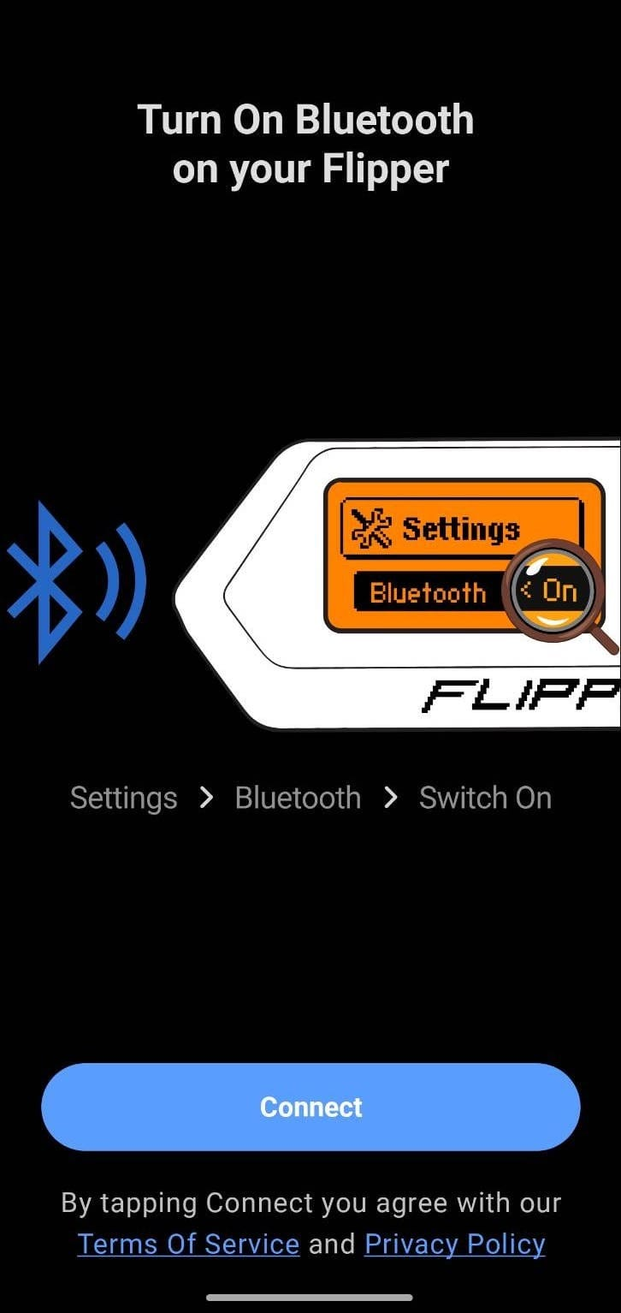
Figure 10.4 — Flipper Mobile App prompting to turn on Bluetooth on the Flipper (Settings > Bluetooth > Switch On)
- Tap the Connect button in the app to search for nearby Flipper Zero devices.
- Select your Flipper Zero from the list of detected devices.
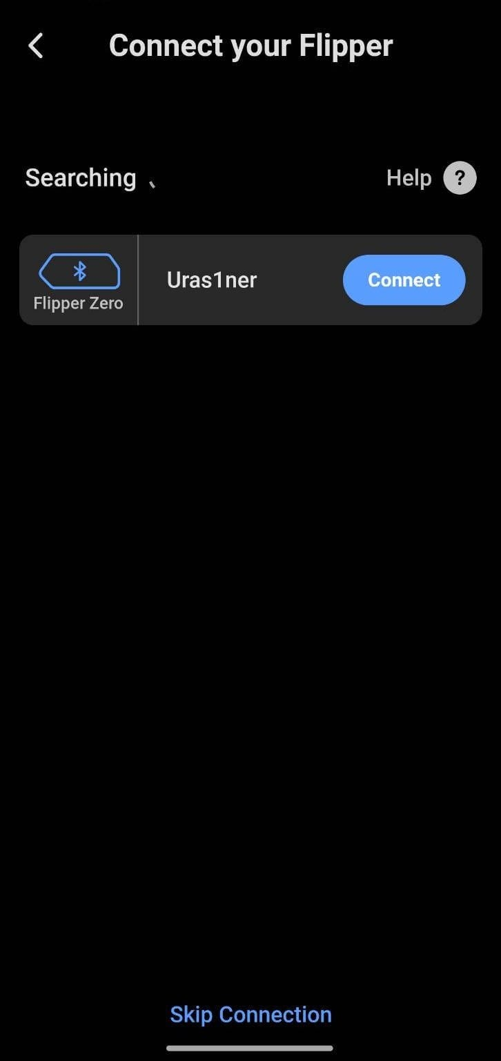
Figure 10.5 — Flipper Mobile App searching and listing the detected Flipper Zero (“Uras1ner”) with a Connect button
- When the pairing code appears on the Flipper Zero screen, enter the same code on the Android phone.

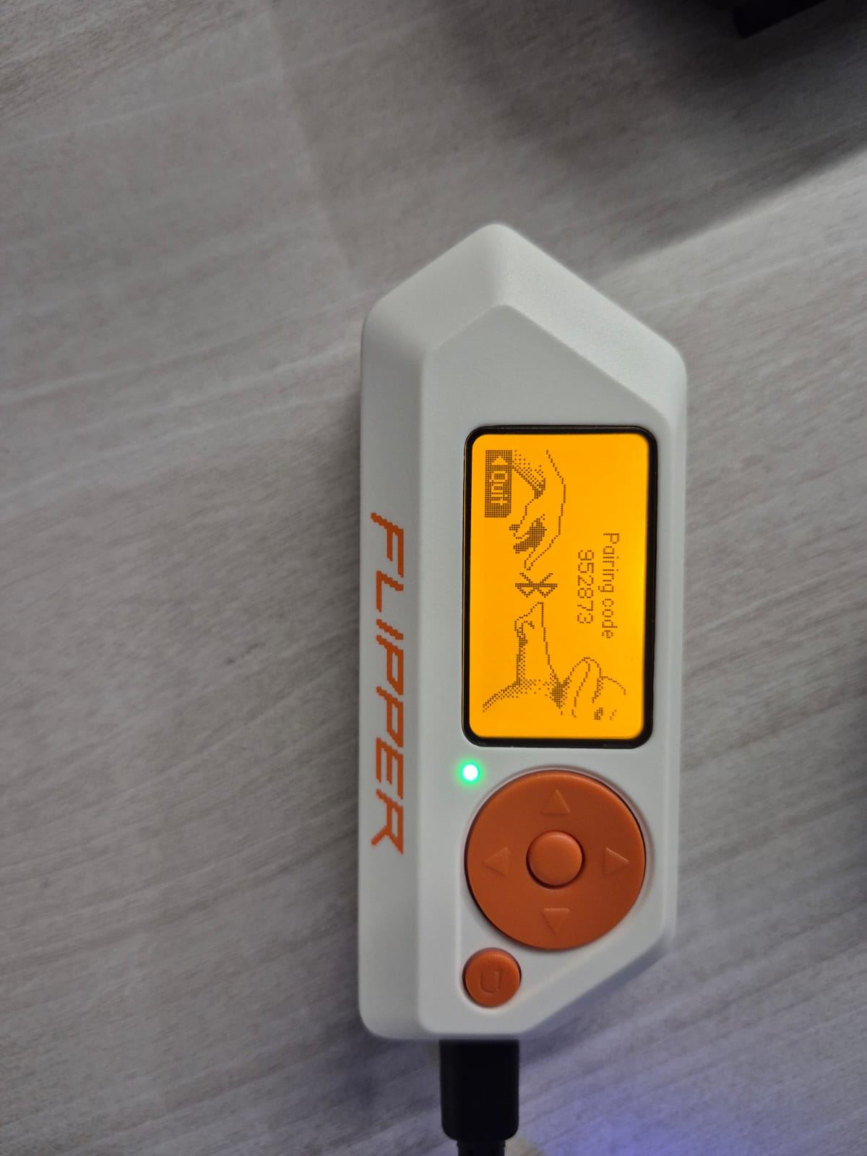
Figure 10.6 — Pairing code displayed on the Flipper Zero screen
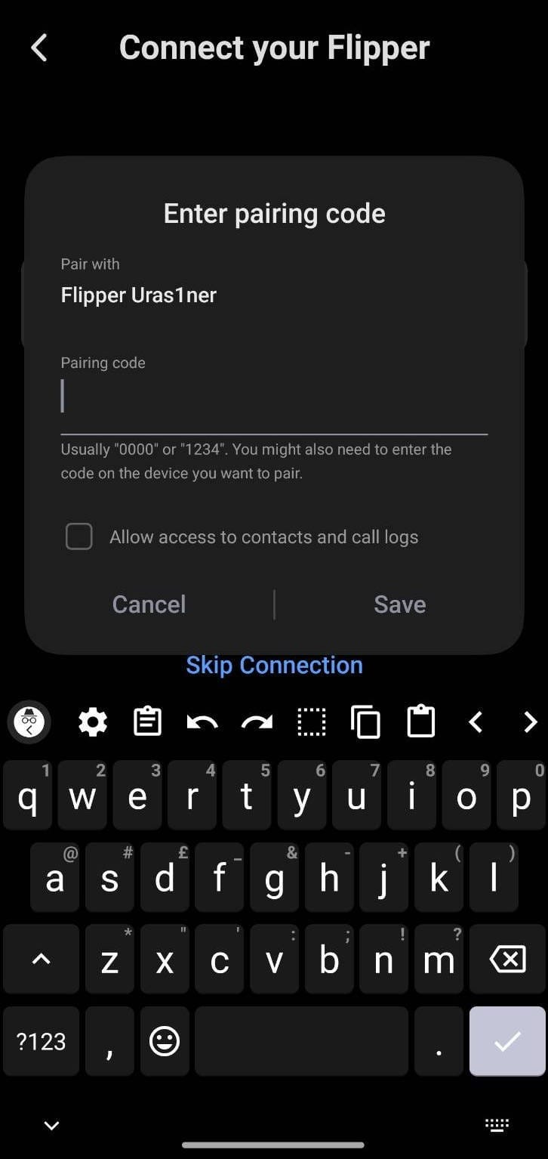
Figure 10.7 — Android Bluetooth pairing code entry prompt
- Confirm the pairing request on the phone to complete Bluetooth pairing.
- Wait for the app to finish synchronizing data with the Flipper Zero.

11. Flipper Mobile App Features and App Installation
Once the Android phone is paired with the Flipper Zero, the Flipper Mobile App provides several core features designed to make everyday use easier without a USB cable.

11.1 Core Features of the Flipper Mobile App
- Firmware and database update: Check for updates and install new firmware and radio databases directly over Bluetooth.
- File manager: Browse, upload, and manage data stored on the Flipper Zero microSD card from the phone.
- Online file sharing: Share keys and dumps with other Flipper users or back up data through online services.
- Apps catalog: Browse an application catalog and install supported apps directly to the Flipper Zero.
- Remote control: Use the phone app to remotely navigate menus and interact with the Flipper Zero screen.
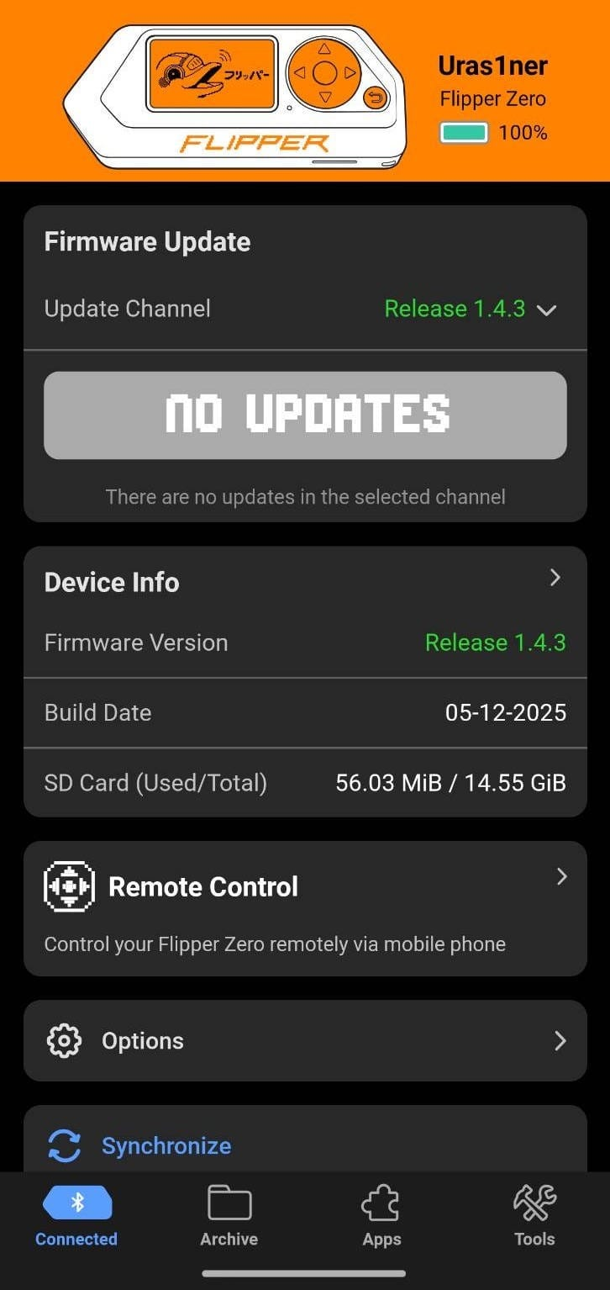
Figure 11.1 — Flipper Mobile App main dashboard: Firmware Update, Device Info, Remote Control, Options and Synchronize
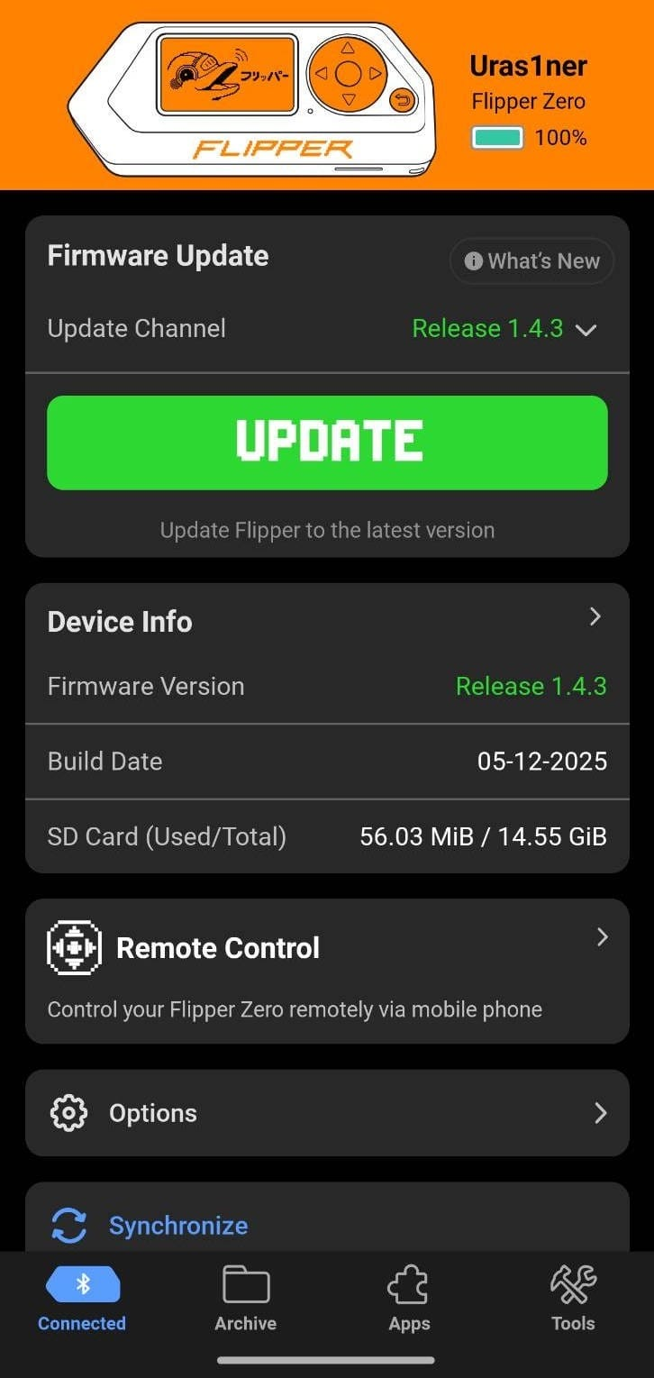
Figure 11.2 — Flipper Mobile App dashboard showing an available firmware Update button

11.2 Installing Apps from the Mobile App Catalog
- Ensure the Android phone is connected to the Flipper Zero via Bluetooth and the device is synchronized.
- In the Flipper Mobile App, open the Hub tab or equivalent section that lists apps.
- Tap Apps to view the applications catalog.
- Browse or search for the app you want to install on the Flipper Zero.
- Tap Install on the app preview or app detail page.
- Wait for the app to upload and install onto the Flipper Zero over Bluetooth.
- On the Flipper Zero, access installed apps from Main Menu followed by Apps.

12. Custom Firmware Overview (Developer Builds and Momentum)
Flipper Zero supports community-developed custom firmware such as Unleashed, Xtreme, and Momentum, as well as official developer builds. This SOP does not require installing custom firmware, but operators should understand the possibilities and risks for future advanced work.

12.1 Official Developer Firmware Builds
- Developer builds are based on the official firmware but include newer features and changes that are still under testing.
- They are useful for contributing to development, testing upcoming features, or building custom tools.
- Developer builds may be less stable than Release firmware and are not recommended for beginners or critical lab demonstrations.

12.2 Momentum and Other Community Firmware
- Momentum firmware is a feature-rich custom firmware that builds on community work and adds advanced customization, asset packs, security features, and extended apps.
- Other well-known firmware projects, such as Unleashed and Xtreme, focus on unlocking additional protocols, adding more applications, and expanding radio and NFC capabilities.
- Custom firmware often provides expanded app catalogs, enhanced Sub-GHz tools, more NFC parsers, visual themes, and advanced utilities beyond the official firmware.
- Using custom firmware can affect compatibility with the Flipper Mobile App and official support channels, so it should be installed only on dedicated lab devices with supervisor approval.

